POWER
20 to 60 Volts DC (48V nominal) [Modular]
Wi-Fi
Dual-band Wi-Fi (IEEE802.1 b/g/n/ac, 2.4GHz/5GHz)
PROCESSOR
MediaTek MT7621, 512MB DDR, 32MB/64MB Flash.
iSense

DATA SHEET

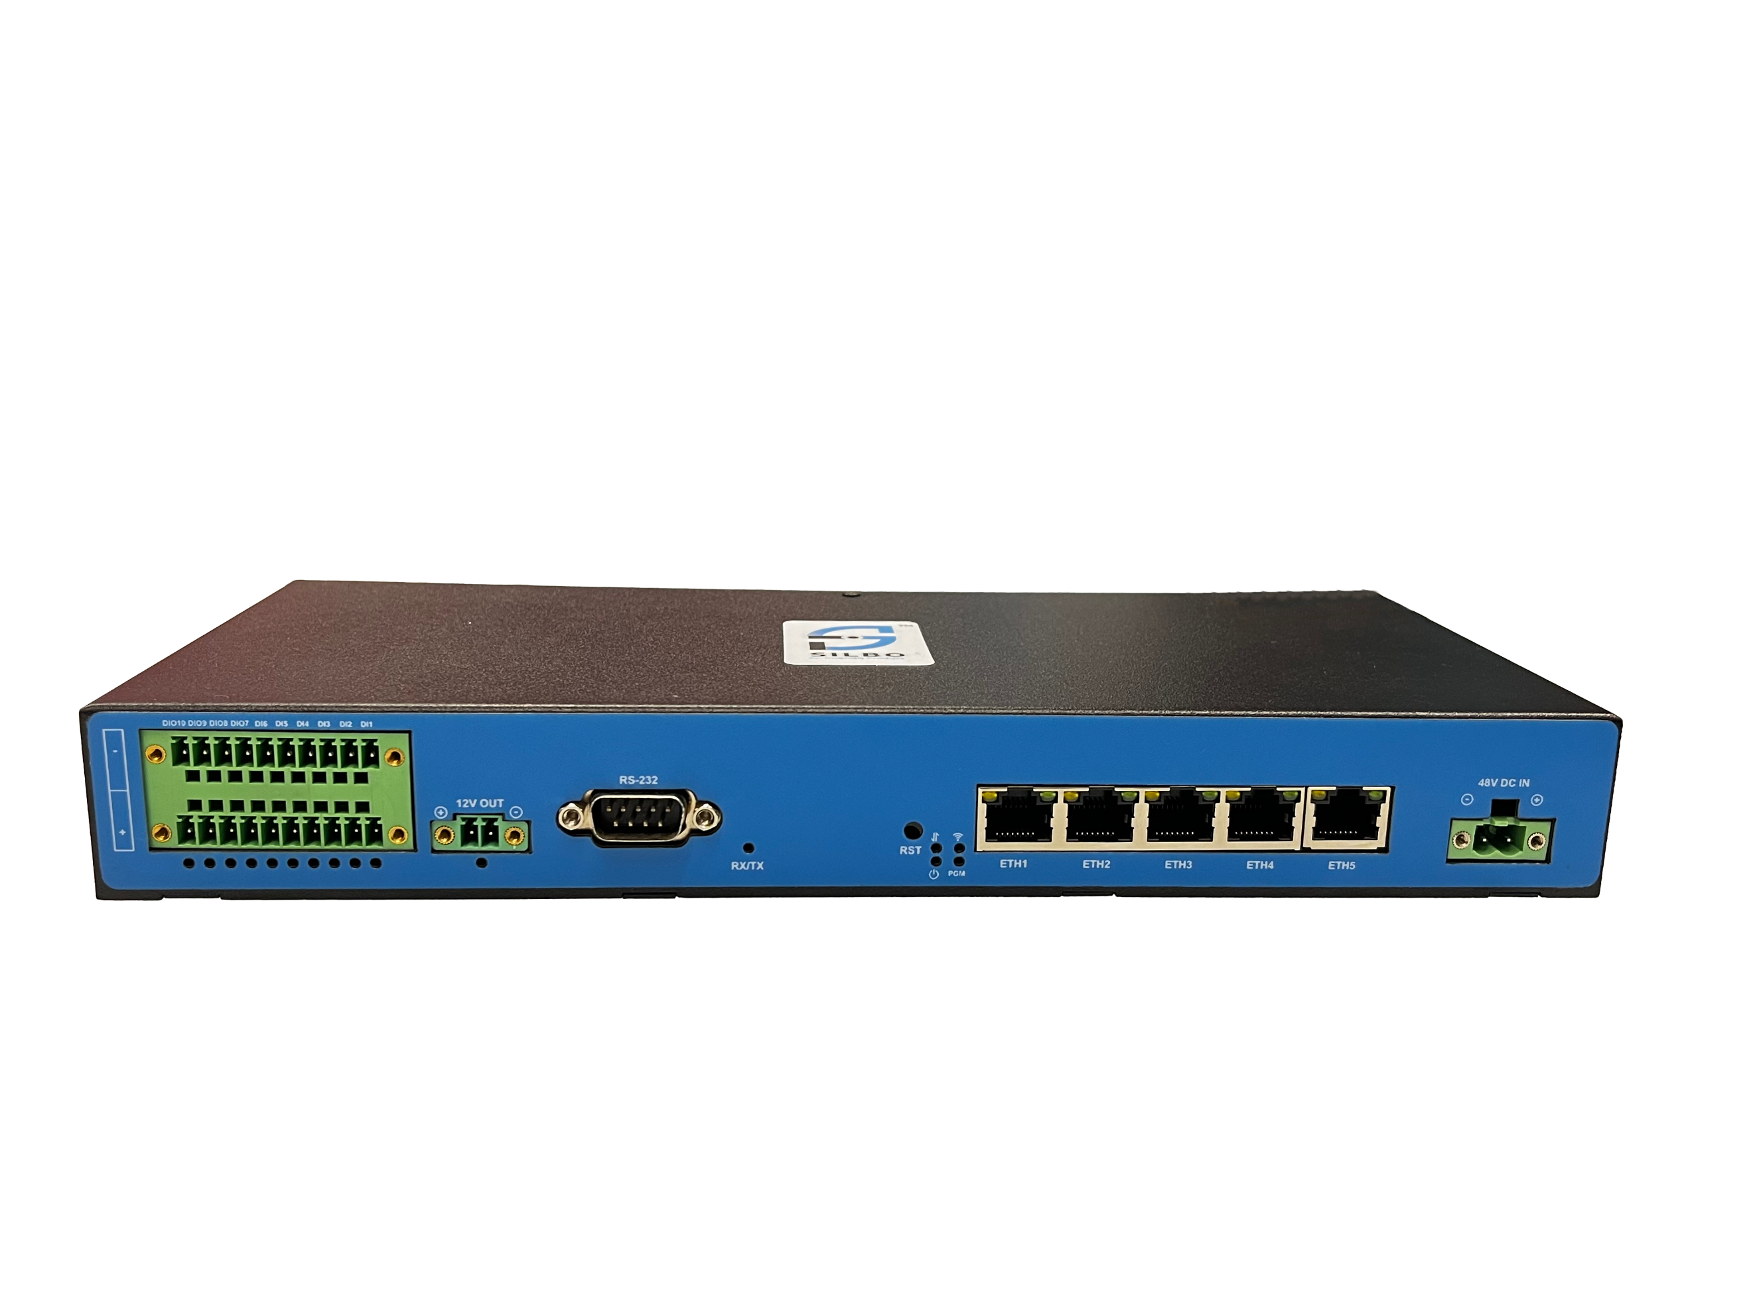
PRODUCT INFO

CELLULAR
Single / Dual SIM with Quad Band CAT4/CAT6/CAT12 GSM/GPRS/GPS/2G/3G/4G/5G [M.2 Based]

INTERFACE
1 WAN & 4 LAN 10 /100 / 1000 Mbps, 1 RS232 port [DB-9], 2 X Isolated RS485 (Half Duplex) port [3 pin terminal]

OPERATING SYSTEM
Linux
Hardware Speciﬁcation
CPU | MediaTek MT7621
RAM | 512MB
FLASH | 32 / 64 MB Flash
Ethernet | 5x 10/100/1000 (Configurable WAN/LAN)
Serial Interface
- Digital Inputs | 12V / 24V with isolation, 6 Digital Inputs
- Digital outputs | 4 DIO's 12V Based
- Temperature Sensor | 1 RTD Port (2 Can be connected on the same port)
- Analog Input (Voltage) | 2 with Isolation (Range: -60 to 60V) + 2 Optional
- Analog Input (Current) | 2 with isolation (Range: 4-20mA) + 2 Optional
- RS485 | 2 X Isolated RS485 (Half Duplex) port [3-pin terminal]
- RS232 | 1 RS232 port [DB-9]
SIM | 2x Nano SIM (1x Active & 1x Passive)
Wi-Fi | 802.11 b/g/n/ac
RTC | Onboard RTC with battery backup
Reset | Pinhole Reset Button
Antenna | Cellular: 2x SMA Connector, Wi-Fi: 4x SMA connector
Status LED | On-board LED for status indication(Power, Cellular ACT, Wi-Fi, Programmable LED etc)
Power Connector | 2-pin Screw Terminal connector
Input Voltage Range | 9-30 Vdc
Enclosure | TBD Sheet Metal with Powder coating
Mounting | Rack Mount (45 mm Depth)
Design | Fanless
Dimensions | 290 x 38 x 124 mm (W x H x D)
Weight | 1856 gm
Other | Grounding Screw

Storage Temperature | -40°C to 85°C
Operating Temperature | -10°C to 70°C
Humidity | 90% non-condensing
Operational & Environmental

SOFTWARE SPECIFICATIONS
Cellular
Cellular Module | 4G (LTE) - Cat 4 up to 150 Mbps, 3G - up to 42 Mbps, 2G - up to 236.8 Kbps (Optional 5G)
Status | Single strength (RSSI), SINR, RSRP, RSRQ
Band Management | Auto/User configurable
Operator Lock | Automatic/Manual
APN | Configurable, Auto APN
Modem conﬁguration mode | Single SIM, Dual SIM
SIM switching | Signal strength, ICMP echo, Data limit based
PDP Type | IPv4, IPv6, IPv4v6
SIM Authentication | PAP,CHAP, No Authentication
SMS | Send SMS, Read SMS, SMS Commands

Routing | Static routing, Advanced Static Routing, Dynamic Routing
Network Protocols | TCP, UDP, IPv4, IPv6, ICMP, NTP, HTTP, HTTPS, SCP, PPP, SSH, DHCP
Connection Monitoring | Ping Reboot, Scheduled Periodic Reboot
Firewall features | Port forward, trafﬁc rules, SNAT, Zone forwarding, Parental Control, Masquerading, MSS Clamping, Loopback IP, Loopback Rules.
Attack Prevention | SYN Flood Protection, Drop Invalid Packets
DHCP | Static and Dynamic
Multi-WAN Conﬁguration | Conﬁgurable Failover, load balancing between Cellular WAN, Wi-Fi WAN and Wired.
VLAN | Tagged VLAN, Untagged VLAN
VPN | Open VPN, IPsec, GRE, L2TP, PPTP, Wireguard, Zero Tier, IPIP Tunnel
Open VPN | TUN/TAP with TLS Certiﬁcates
IPsec | IKEv1, IKEv2, Aggressive/Main Mode
IPsec Encryption | 3DES, AES128, AES192, AES256
IPsec Authentication | SHA1, MD5, SHA256, SHA384, SHA512
IPsec DH Group | MODP768, MODP1024, MODP1536, MODP2048, MODP3072, MODP4096
PPTP/L2TP | Server & Client with/without MPPE Encryption
Monitoring Application | Modem Monitoring with ICMP Echo, Router Monitoring with ICMP Echo
Time Synchronization | NTP Client, RTC, Manual
Diagnostic | Ping, Traceroute, Modem Debug Info, Iperf, Download Logs
Other Features | MAC binding, Connection Diagnostics, URL Filtering, Router Health Monitoring, Package Manager
Firewall & Networking
Remote Management
NMS | Remote Monitoring & Management Platform for SILBO Networking products
NMS VPN | Remote Access of SILBO and non-SILBO Networking Devices
TR069 | TR069 Client for CPE Management
SMS Commands | Reboot Command, Uptime Command

Gateway

Gateway Protocols | Modbus TCP Slave, Modbus TCP Master
Serial Mode | Transparent (Over IP), Modbus Gateway
Data sender | SNMP, HTTP, MQTT
Internal Storage | 4GB eMMC(optional)

Operating System

Operating System | Open-WRT based Linux OS
Supported Languages | Shell scripting, C, C++
Development tools | SDK package with built environment provided (Optional)
Standard Packaging

iSense Cellular Gateway with Sheet Metal Housing, 4x Wi-Fi Rubber Duck Antennas, 2x Cellular Rubber Duck Antennas, 0.5-meter Power Cord, 01-meter Ethernet cable, Serial interface connectors.

*All rights reserved, subject to change without prior notice.
Get in touch:
sales@invendis.com
www.silbonetworks.com
Invendis Technologies India Private Limited
No. 230, 1st Cross, 38th Main, BOOHBCS Layout, BTM 2nd Stage, Bangalore – 560 068






